
CERTIFICATE of DEDICATION
This certifies that
ELAIZA E. MABANDOS
WAS DEDICATED TO GOD
At Fundamental Baptist Mission, Purok 2, Villangit, Sibagat, Agusan Del Sur.
On the 24th day of January in the year of 2026.
Father: Esaganie H. Mabandos
Mother: Mabet L. Engyo
Birthday: October 12, 2022
Officiated by: Pastor Elven B. Lumalad

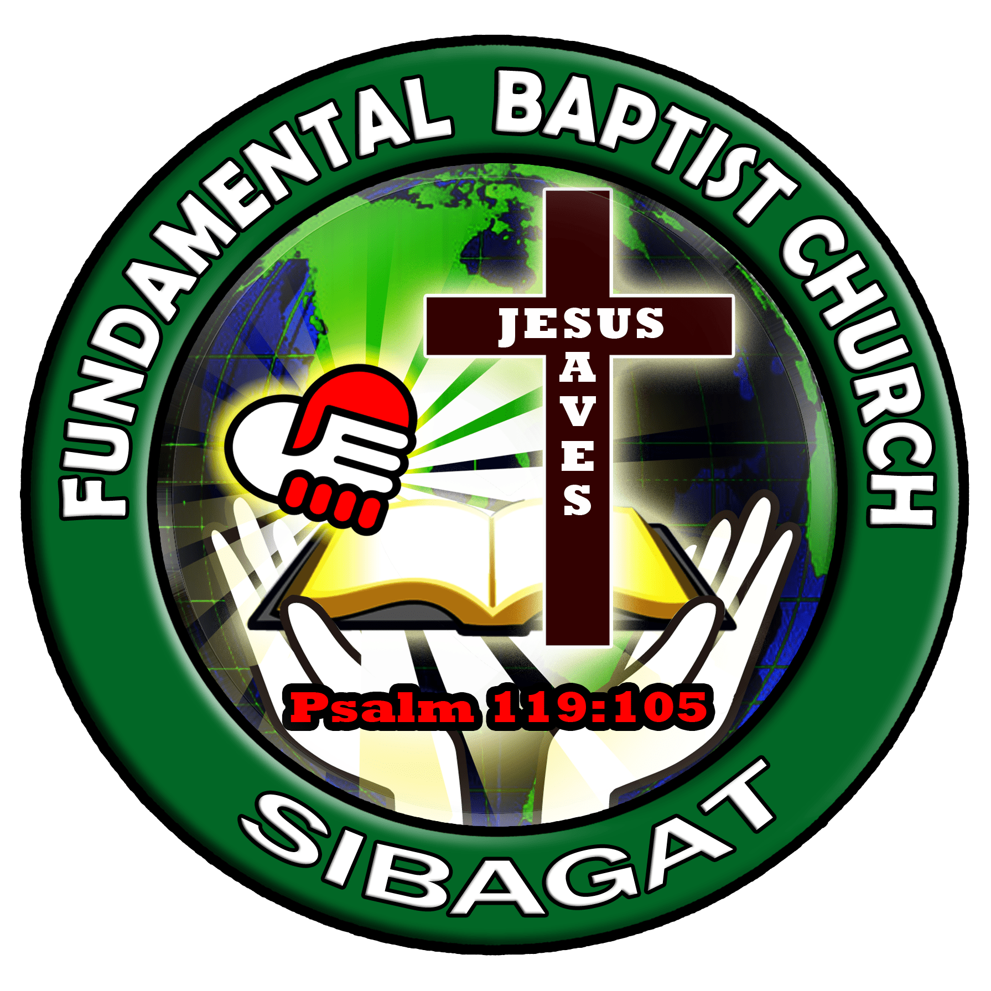
“Let the little children come to me, and do not hinder them, for the Kingdom of God belongs to such as these.”
Mark 10:14 (NIV)

